

**STIA1113 PROGRAMMING 1**

**FIRST SEMESTER SESSION 2021/2022 (A211)**

**TOPIC:**

**UNIVERSITY**

**PREPARED FOR:**

**PROF. MADYA DR. AZMAN BIN YASIN**

**PREPARED BY:**

**GROUP 4**

|  |  |  |
| --- | --- | --- |
| **NO.** | **NAME** | **MATRICS NO.** |
| **1.** | **SITI NUR AISYAH BINTI ABDULLAH** | **286752** |
| **2.** | **NUR ALYA BINTI MOHD IZAZI** | **286814** |
| **3.** | **TANG WEI CHIANG** | **286841** |
| **4.** | **FARA AYEESHA BINTI AHMAD YUSNI** | **286941** |
| **5.** | **NIK MOHAMAD HANIS BIN NIK YAHYA** | **286961** |

**TOPIC EMPLOYEES - SITI NUR AISYAH BINTI ABDULLAH**

1. **Identify problem:**

In some institutions hourly-paid teaching staff are paid a comprehensive teaching rate for every hour of teaching that is supposed to cover other duties such as preparation, marking, administration and attending meetings. They face a problem when they have hazy understanding of how the salary have been paid according to their types of lecturers. This makes it difficult to calculate an accurate monthly wage.

However, lecturers generally consist of several types or classes. This depends on the offer made by the university. Over time, when a new campus opens, the number of students recruited increases and indirectly, the teaching staff required also increases. Therefore, new employees were recruited to cover the shortage of lecturers.

They are several types of lecturers in university:

1. Permanent Lecturer

Permanent lecturers are lecturers who are confirmed positions in university. The average permanent lecturer has a master’s degree. However, there may still be lecturers with a degree who are serving.

1. Contract Lecturer

Contract lecturers may consist of two small groups either from scholarship holder or from lecturers who have served for a long time and were appointed to contract positions. For the scholarship holder lecturer, the contract lecturer referred to here is a probationary period before being confirmed for a permanent position. However, they will be called to teach even they has not yet completed their studies. In fact, there are also many lecturers who have served but have not completed their studies in the master’s field.

1. Part Time Full Time Lecturer(PTFT)

In some places, it is also known as a package lecturer. PTFT lecturers only needed while waiting for the return of the contract lecturer according to the semester. Unlike permanent or contract lecturers, there salaries are paid by the Malaysian government. If the government announces a bonus, this bonus is only enjoyed by permanent or contract staff. In fact, PTFT only gets a basic salary.

1. **Understanding the problem:**

A salary or wages is the payment typically paid on monthly basis. The lecturers who are teaching at Universiti Utara Malaysia (UUM) are paid per hour according to their respective work codes. 10% and 0.5% of the salary will be deducted to the Employees Provident Fund (EPF) and Employee SOCSO, and they will get an allowance for every month. They have to keep the pay slip for future use and the pay slip must have detailed information such as name, identification number, work code, month of payslip, amount of allowance and deduction and the net salary. The table below show the general information for lecturers use to key in their details. They have to key in other information such as name and identification number to confirmed their salary.

|  |  |  |  |
| --- | --- | --- | --- |
| Types of lecturer | Permanent Lecturer | Contract Lecturer | PTFT Lecturer |
| Work code | DPL45 | DCL51 | DP441 |
| Salary per hour | RM132.00 | RM85.00 | RM63.00 |
| Allowance | RM900 | RM800 | RM0 |

1. **Alternative ways:**
2. Lecturers just receive the payment by bank transfer without well documented.
3. Lecturers have to check their salary with digital access by using the information that prepared and insert their detailed information as well.
4. Lecturers check their salary and print out the pay slip.

**4.** **Best way(2):**

The best way to solve this problem is way (ii). This is because, the data input process for the lecturer's payment will easier since the system used has digital access. Compared to way (i) and (iii), way (ii) will minimize the difficulties to use the payslip in future use. Furthermore, the financial data is recorded more clearly and it will prevent from loss and damage.

**5.** **Instruction:**

1. Lecturer have to enter their name, identification card number, work code and month of payslip.
2. Lecturer insert an input such as hour of work, salary per hour and allowance for system save and calculate their salary based on details.
3. System calculates the basic salary by use the formula:

basic salary = salary per hour*hour

1. System calculates the amount of deduction by use the formula:

EPF= 0.1*basic salary

SOCSO=0.005*basic salary

amount of deduction= EPF+SOCSO

1. System calculates the net salary based on basic salary and amount of deduction

net salary = basic salary - amount of deduction

1. System display the payslip contains their information and net salary.

**6.** **Evaluate the solution**

The solutions fulfil the requirement to solve the problem that have been stated. Lecturers must insert their information to system for process. First of all, the system will calculate basic salary based on salary per hour and hour of work. Next, system will calculate the amount of deduction by adding the amount of EPF and SOCSO together. Lastly, the system will calculate the net salary by deduct the basic salary with amount of deduction. Later, the system displays the lecturer’s info and the wage’s info on the payslip.

**7.** **Algorithm**

Basic Salary = (Salary per hour × hour) + Allowance

EPF = 0.1 × Basic salary

SOCSO = 0.005 × Basic salary

Amount of deduction = EPF + SOCSO

Net salary = Basic salary – Amount of deduction

**8.** **Pseudocode**

Start

input name, ic, workCode, monthOfpayment, hour, salaryPerhour, allowance

basicSalary = (salaryPerhour*hour) + allowance

epf = 0.1*basicSalary

socso = 0.005*basicSalary

amountOfdeduction = epf+socso

netSalary = basicSalary-amountOfdeduction

output name, ic, allowance, basicSalary, amountOfdeduction, netSalary

Stop

**9.** **Flowchart**









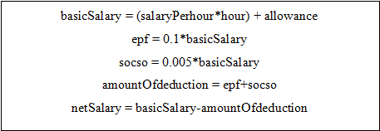









**10.** **Coding**

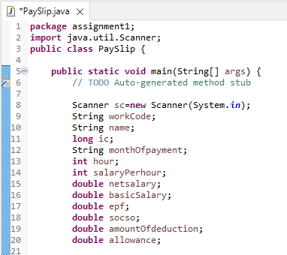

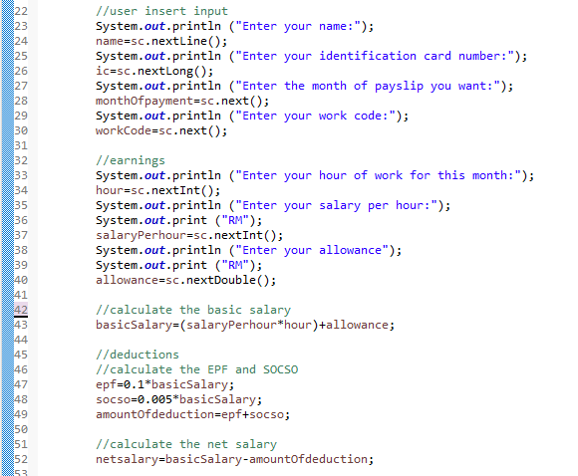

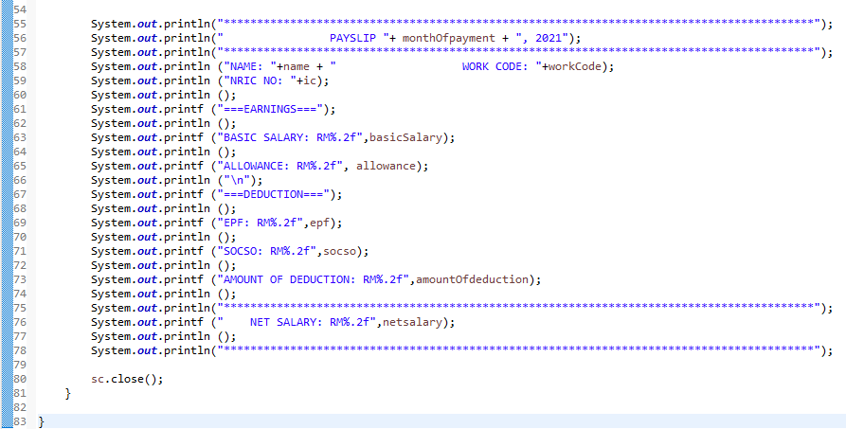

**Output**

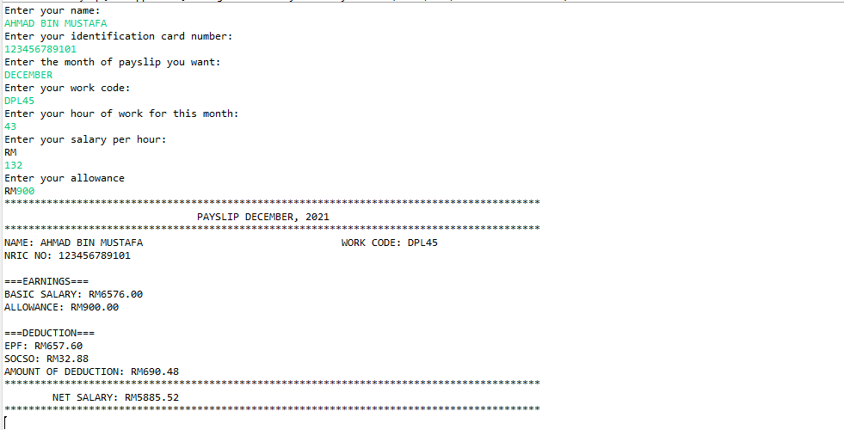

**TOPIC STUDENT- NUR ALYA BINTI MOHD IZAZI**

1. **Identify the problem**

Universities in Malaysia are often become the choice of students from abroad to pursue their studies because of the quality of teaching provided and also well-experience lecturers who teach at universities. Not only that most international students decided to pursue their studies at university in Malaysia because of the facilities provided starting from transportation facilities that help students to move from one place to another, internet network facilities, library services for students to review lessons, comfortable lecture halls, sophisticated devices and comfortable accommodation for students.

1. **Understand the problem**

Students who are decided to stay at the residential college in the university are required to pay for the room fee. For the students that are Malaysian, they are allow to choose between two college which is Syed Residential College and Zain Residential College. For the international students they can only choose Syed Residential College. Syed Residential College’s room give the student more benefit from the facility that are provided meanwhile Zain Residential College’s room provided the students the normal facility. The price for the Syed Residential’s room is three time more expensive than Zain Residential College’s room Discounts 80% will be given to the students who are active in the university activities by getting mark more than 70. Write a programme that will show the balance fee of Residential College that student need to pay based on the type of Residential College that were chosen and the student’s co-curriculum mark.

|  |  |  |
| --- | --- | --- |
| **Achievement** | **Category** | **Mark** |
| **Participation on residential college organization** | **chairman** | **12** |
| **Deputy chairman** | **10** |
| **Secretary** | **8** |
| **Treasurer** | **8** |
| **Committee member** | **6** |
| **Participation on university organization** | **Chairman** | **15** |
| **Deputy chairman** | **13** |
| **Secretary** | **10** |
| **Treasurer** | **10** |
| **Committee member** | **8** |
| **Excelled in academic** | **CGPA 3.5 – 4.0** | **10** |
| **Involvement in university club organization** | **Chairman** | **10** |
| **Deputy chairman** | **8** |
| **Secretary** | **7** |
| **Treasurer** | **7** |
| **Committee member** | **5** |
| **participants** | **3** |
| **Involvement in university sport day** | **Chairman** | **8** |
| **Deputy chairman** | **7** |
| **Secretary** | **6** |
| **Treasurer** | **6** |
| **Committee member** | **4** |
| **participants** | **2** |
| **Participation in university activity** | **International level** | **10** |
| **National level** | **8** |
| **University level** | **7** |

1. **Alternative Method**

(i)Write a program that can calculate the balance fee based on the total co-curriculum mark and college name.

(ii)Lecturer have to calculate manually balance fee that student need to pay based on the total co-curriculum mark and college name and send the details through email to the students.

1. **Best Way**

The best way to solve this problem is by using number (i) method. Number (i) method help the lecturer to manage student payment matter easier and can save more time than using number (ii) method.

**5. Instructions**

1. Key in the student information and details and key in whether the student is from Malaysia or the student is an international student.

2. The program will give the option for the students who are from Malaysia to choose between Zain Residential College or Syed Residential College.

3. For the international student the program will only give student one option which is Syed Residential College.

4. Key in the student total co-curriculum mark based on the achievement and category.

5. The program will calculate the residential college fee after discount for the students who get a mark more than 70.

(when key in Zain Residential College)

balanceFee=(collegeFee*1)

balanceFee=(balanceFee*0.2)

(when key in Syed Residential College)

balanceFee=(collegeFee*3)

balanceFee= (balanceFee *0.2)

6. The program will directly show the residential college fee for the student who get mark less than 70.

balanceFee= collegeFee (when key in Zain Residential College)

balanceFee= (collegeFee*3) (when key in Syed Residential College)

1. The system will print out the student details, total co-curriculum mark and balance fee.

**6.Evaluate the Solution**

The solution meets the requirement to solve the problems stated. The balance fee of Residential College that student need to pay is calculated based on the college name and the total of co-curriculum mark. The calculation of the balance Fee will begin when student key in their college name that are choose and total co-curriculum mark. The system will print out the student’s detail, the college name that are chosen, the total co-curriculum mark and the balance fee.

**7.Algorithm**

balanceFee = (collegeFee*3)

balanceFee = (balanceFee*0.2)

**8.Pseudocode**

Start

Declare name, countryName = “Malaysia”, sem, collegeName = “Syed Residential

College”, totalCocumark = 80, balance Fee, collegeFee = 160.99

Output “Please key in your name: “

Input name

Output “Please key in what semester are you now: “

Input sem

Output “Please key in your country name: “

Input countryName

Output “Please key in your choice: “

Input collegeName

Output “Please key in your total cocurriculum mark:”

Input totalCocumark

Display name

Display sem

Display countryName

Display collegeName

Display totalCocumark

Display balanceFee

Output “Total balance fee.”

End

**9.Flowchart**

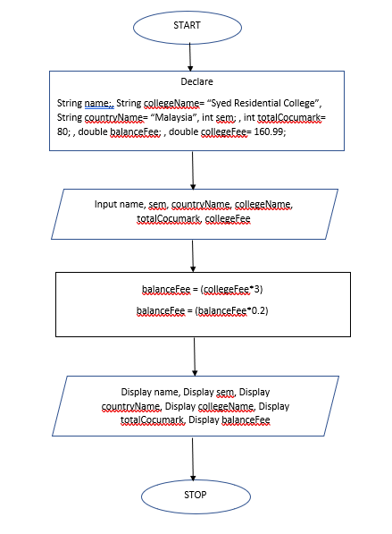

**10.Coding**

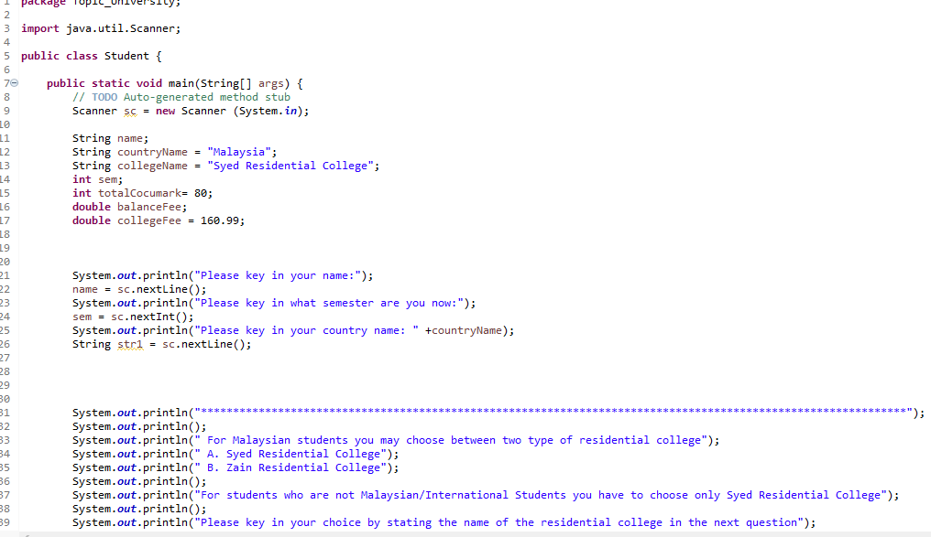

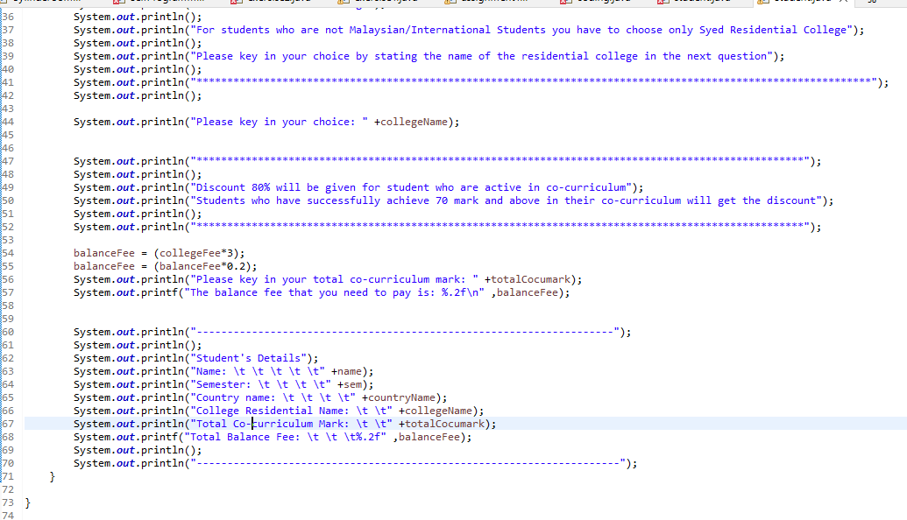

**Output**

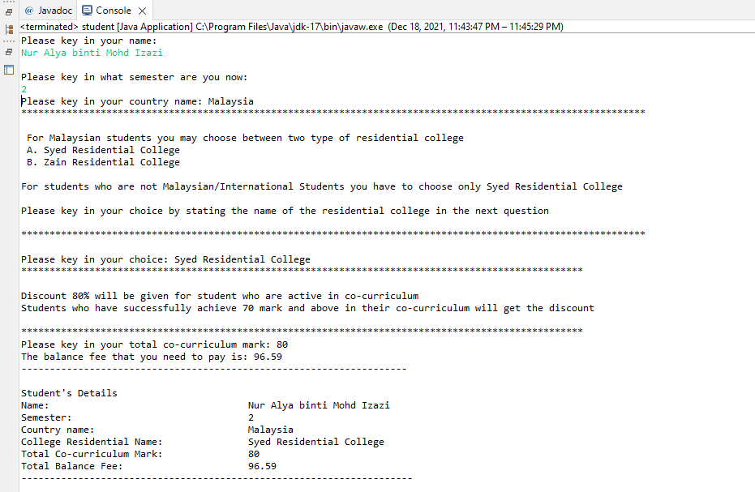

**TOPIC COURSE – TANG WEI CHIANG**

1. **Identify the problem**

A course is a syllabus item offered by the University that’s similar to a subject that we may have studied at school. We undertake courses to complete our own program requirements. Courses are identified by a subject area and catalogue number, for example CHEM 1101 is a level 1 Chemistry course. Within each course there will be classes that you enrol into, for example lectures, tutorials, seminars or practical.

In higher education in various countries, such as Canada, Nigeria and the United States, a course is a unit of teaching that typically lasts one academic term, is led by one or more instructors (teachers or professors) and has a fixed roster of students. A course usually covers an individual subject. Courses generally have a fixed program of sessions every week during the term, called lessons or classes. Students may receive a grade and academic credit after completion of the course.

In India, the United Kingdom, Australia, and Singapore, as well as parts of Canada, a course is the entire programme of studies required to complete a university degree, and the word "unit" or "module" would be used to refer to an academic course as used in North America and the rest of Europe. This corresponds roughly to an academic major in the United States system.

In South Africa, a course is officially the collection of all courses (in the American sense, these are often called "modules") over a year or semester, though the American usage is common. In the Philippines, a course can be an individual subject (usually referred to by faculty and school officials) or the entire programme (usually referred to by students and outsiders).

Courses are time-limited in most universities worldwide, lasting anywhere between several weeks to several semesters. They can either be compulsory material or "elective". An elective is usually not a required course, but there are a certain number of non-specific electives that are required for certain majors.

1. **Understand the problem**

Universiti Utara Malaysia (UUM) aka Northern University of Malaysia, which was officially established on 16 February 1984, is the sixth Malaysian public university. UUM consists of two campuses, which is Sintok campus and Kuala Lumpur. UUM divided the college variety into three parts, which is College of Business, College of Arts and Sciences, and College of Law, Government and International Studies. Each college consists of several school. In School of Computing under College of Arts and Sciences, students will undergo course registration in every new semester given a certain period. When students want to register a second-level course, the course requires prerequisite course to register. Means that students want to register course A, they are going to complete course B with requirement, where students need to pass the grade with a minimum of GPA 2.00 and attendance rate of 80% or higher. The GPA will be calculated by using the marks from tests (80%) and coursework (20%). The total attend times for a course is 20. There would be certain course which require more than one prerequisite course, but the passing grade and attendance rate are the same. If student failed to reach the requirements of the secondary-level course they want to register, they are required to retake the prerequisite course until they fulfil the course requirements.

|  |  |  |
| --- | --- | --- |
| **MARKS** | **GRADE POINT** | |
| 90 - 100 | 4.00 | (Excellent) |
| 80 - 89 | 4.00 | (Excellent) |
| 75 - 79 | 3.67 | (Good) |
| 70 - 74 | 3.33 | (Good) |
| 65 - 69 | 3.00 | (Good) |
| 60 - 64 | 2.67 | (Satisfactory) |
| 55 - 59 | 2.33 | (Satisfactory) |
| 50 - 54 | 2.00 | (Pass) |
| 45 - 49 | 1.67 | (Fail) |
| 40 - 44 | 1.33 | (Fail) |
| 35 - 39 | 1.00 | (Fail) |
| 0 - 34 | 0.00 | (Fail) |
| 0 | 0.00 | (Barred) |
| 0 | 0.00 | (Withdraw) |

Minimum passing GPA

|  |  |  |
| --- | --- | --- |
| Attended Times | Total Attend Times | Attendance Rate (%) |
| 20 | 20 | 100 |
| 19 | 20 | 95 |
| 18 | 20 | 90 |
| 17 | 20 | 85 |
| 16 | 20 | 80 |
| 15 | 20 | 75 |
| 14 | 20 | 70 |
| 13 | 20 | 65 |
| 12 | 20 | 60 |
| 11 | 20 | 55 |
| 10 | 20 | 50 |
| 9 | 20 | 45 |
| 8 | 20 | 40 |
| 7 | 20 | 35 |
| 6 | 20 | 30 |
| 5 | 20 | 25 |
| 4 | 20 | 20 |
| 3 | 20 | 15 |
| 2 | 20 | 10 |
| 1 | 20 | 5 |
| 0 | 20 | 0 |

Minimum attendance rate

1. **Alternative method**
2. A system that can both calculate GPA using test mark and coursework mark, calculate attendance rate using attended time and total attend times.
3. Develop an add drop system
4. Develop a CGPA calculating system
5. **Best method**

The (i.) way is the best method as it fulfilled the problem stated where calculation of GPA using tests mark and coursework mark and calculation of attendance rate using attended time and total attended time. The (ii.) way wasn’t clear to solve the problem as it only stated to add and drop something. The (iii.) way also didn’t solve the problem as it calculate CGPA where only GPA are required in the problem stated.

1. **Instructions**
2. Get personal info from user (name, id, sem)
3. Get user about course information (registeredCourse, testMark, courseworkMark, attendedTimes)
4. Get the scdLvlCourse, display the course requirements (Completed prerequisite course required with minimum GPA 2.00 and attendance rate 80% or higher)
5. Calculate test mark (Test 1 + Test 2)
6. Calculate the total mark of registered course (testMark + courseworkMark)
7. Display total mark and GPA
8. Calculate the Attendance Rate (attendedTimes/totalAttendTimes)*100
9. Display attendance rate
10. Determine whether the registered course fulfils the requirements of second-level course. If fulfilled, move on to next registration. Else, retake the registered course.
11. **Evaluate the solution**

The solution meets the requirement to solve the problems stated. Firstly, the registered course tests mark and coursework mark is summed up into total mark. The total mark will be based on the grading table that determines the course GPA. Next, the system will also calculate the attendance rate of the registered course by student. As student has keyed in the number of attended times of registered course, the system will calculate the attendance rate using the data keyed in with the total attend times. And so, both the GPA and attendance rate of the registered course has been calculated and displayed, it will determined whether student is allowed to register the second-level course.

1. **Algorithm**

Tests Mark = Test 1 Mark + Test 2 Mark

Total Mark = Test Mark + Coursework Mark

Attendance rate =

1. **Pseudocode**

START

Declare regCourse, testMark1, testMark2, courseworkMark, totalMark, scdLvlCourse, attTime = n, totalAttTime = 20, minGPA = 2.00, GPA, minAttRate = 80, attRate.

OUTPUT “Enter registered course: ”

INPUT registered course

OUTPUT “Enter test mark 1: ”

INPUT test mark 1

OUTPUT “Enter test mark 2: ”

INPUT test mark 2

OUTPUT “Enter coursework mark: ”

INPUT coursework mark

DISPLAY attended time

OUTPUT “Enter second-level course you want to register: ”

INPUT second-level course

OUTPUT course requirements

testsMark = testMark 1 + testMark2

totalmark = testsMark + courseworkMark

attRate = (attTime / totalAttTime) * 100

OUTPUT tests mark

OUTPUT coursework mark

OUTPUT total mark

OUTPUT GPA

OUTPUT total attend time

OUTPUT attended time

OUTPUT attendance rate

OUTPUT “Student passed the GPA and attendance rate requirements, proceed to next registration.”

OUTPUT “Student passed the GPA requirement but failed to fulfilled attendance rate, please retake the course.”

OUTPUT “Student passed the Attendance rate requirement but failed to fulfilled GPA, please retake the course.”

END

1. **Flowchart**

Start

Stop

Declare

regCourse, testMark1, testMark2, courseworkMark, totalMark, scdLvlCourse, attTime = n, totalAttTime = 20, minGPA = 2.00, GPA, minAttRate = 80, attRate

Input regCourse, testMark1, testMark2, courseworkMark, scdLvlCourse.

testsMark = testMark1 + testMark2

totalMark = testsMark + courseworkMark

attRate = (attTime / totAttTime) * 100

Display tests mark

Display coursework mark  
Display total mark

Display GPA

Display total attend time

Display attended time

Display attendance rate

Output “Student passed the GPA and attendance rate requirements, proceed to next registration.”

Output “Student passed the GPA requirement but failed to fulfilled attendance rate, please retake the course.”

Output “Student passed the Attendance rate requirement but failed to fulfilled GPA, please retake the course.”

1. A picture containing text

   Description automatically generated**Coding** A picture containing text

   Description automatically generated

**Output**

**TOPIC LIBRARY - FARA AYEESHA BINTI AHMAD YUSNI**

1. **Identify the Problem**

A library is a place where people read and borrow books. It is a specially made location to store books and information so that anyone can easily access it no matter their status. However, in allowing people to borrow books, there is a problem wherein books are not being checked in according to the designated times. This creates a headache for librarians in being unable to lend the books to other people who has requested for it.

A lot of ways has been done to help mitigate this problem such as sending a reminder to the borrower’s home address, banning them from future borrowing of books from the library, or charging fines to cover the loss of the books.

1. **Understand the Problem**

The librarian in a local university has made a decision to charge students who return books late to the library with a fine. The fine is different for every student. The base fine for each days late is RM1.00. An additional fine will be imposed based on the student’s years of study. For first years, the additional fine is RM1.00 per day. For second years, the additional fine is RM2.00 per day. For third years, the additional fine is RM3.00 per day. If they have different books with different check out times, it will be calculated independent of each other.

|  |  |  |  |
| --- | --- | --- | --- |
| Year of Study | 1st Year | 2nd Year | 3rd Year |
| Base Fine Per Day | RM1.00 | RM1.00 | RM1.00 |
| Additional Fine Per Day | RM1.00 | RM2.00 | RM3.00 |

1. **Alternative Method**
   * + 1. Write a program that can calculate the total fine based on the student’s year of study, number of days late, and fine per day.
       2. Write a program that can calculate the total fine based on the student’s year of study, number of days late, and fine per day, calculating independently if there are more than 1 book.
       3. Write a program that can calculate the total fine for all students and listing their name in one huge list.

1. **Best Method**

(ii.) way because it is more detailed and clearer compared to (i.) and (iii.). It fulfills the librarian’s request of charging each student according to the accumulated fines.

1. **Instructions**
2. User enters the student’s name, student ID
3. User inputs the book title and ISBN number
4. User inputs student’s years of study and number of days late
5. The program calculates the total fine with the formula  
   total fine = (RM1.00*number of days late) + (additional fine*number of days late)
6. System prints out a slip containing the student’s name, student ID, years of study, total fine, and number of days late.

1. **Evaluate the Solution**

The solution meets the requirement to solve the problems stated. The fine for the late delivery of one book is calculated based in the student’s year of study and the number of days late. With books of different duration of late time, the fine will be calculated independent of the first book. The system will then display the student’s info, the books’ info, the total fine, and the number of days late for each book.

1. **Algorithm**

totalFine = (daysLate*yearCode) + (daysLate*1)

1. **Pseudocode**

Start

Declare String name, int studentID, int yearCode, int daysLate, int totalFine, int   
numBooks, String bookTitle, String ISBN

Output “Enter name: “

Input name

Output “Student ID: “

Input studentID

Output “Year of study: “

Input yearCode

Output “Number of books: “

Input numBooks

Output “Number of days late: “

Input daysLate

Display name

Display studentID

Display yearCode

Display daysLate

Display bookTitle

Display ISBN

Display totalFine

Output “**Please pay at the counter.”

End

1. **Flowchart**

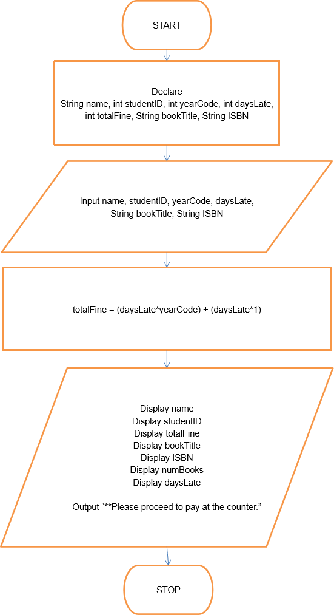

1. **Coding**

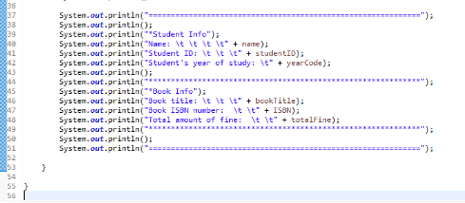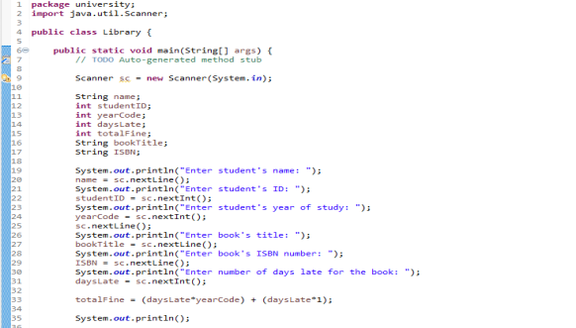

**Output**

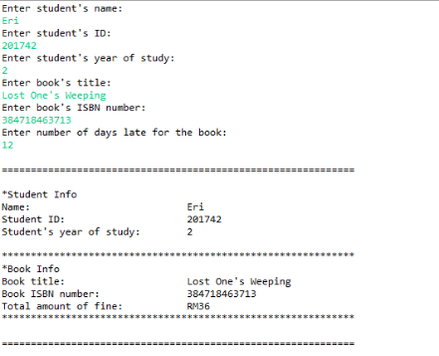

**TOPIC MEDICAL - NIK MOHAMAD HANIS BIN NIK YAHYA**

1. **Identify the problem**

The outbreak of corona virus diseases (COVID-19) has been substantially influencing the life and living of people across the world, especially after the declaration of a global pandemic by the World Health Organization in the second week of March 2020. This unprecedented 'home isolation' under lockdown, along with the uncertainty of academic and professional careers, has had a variety of effects on students' mental health. Based on many published studies, longer duration of quarantine has made some of the students affected by mental health disorders such as stress, anxiety, and depression (SAD).

Most of the students in Malaysia are having a problem with online class during pandemic because they have to adapt to a new situation which is more struggling and harder for them. Learning through online platforms have given rise to depression and anxiety disorders among undergraduate university students, where there was a significant correlation between student satisfaction and prevalence of depression, anxiety, and stress.

1. **Understand the problem**

Ahmad is a medical student who studied at University Utara Malaysia (UUM) and currently in semester 3. According to current situation where students must study through online platforms and cannot attend physical class because of covid-19, Ahmad and his groupmate must do a survey and analysis as a medical student on depression and anxiety among UUM students as their assignment project.

They have made a survey of the level of anxiety and depression among 100 UUM students from different schools, which is 25 students in each school at UUM. All of the students already make responses to their project and Ahmad have been entrusted to keep all the data that the responses made. Unfortunately, Ahmad laptop have been format and only some of the data can be saved.

In conclusion, 25% out of 100 students have reached the anxiety level while 32% of them have reached the depression level. Based on the survey, 2.25% and 1.50% of computing and accounting students have anxiety respectively while law and business students both have the same percentage. 3.52% and 2.88% of students that have depression are from law and computing students respectively. The remaining students are business and accounting students because both of these schools share the same percentage.

Now, they are facing a problem on how to separate that information and calculate the percentage of students, total number of students, female students and male students from each school who have anxiety and depression.

1. **Alternative ways**
2. Ahmad has to do the survey again and saved the data.
3. Ahmad just has to make assumptions on the number of students that have anxiety and depression from each school.
4. Ahmad has to calculates and display the percentage of students, total number of students, female students and male students that have anxiety and depression from each school which is law, computing, business and accounting based on the data given.

1. **Best way**

Ahmad has to calculates and display the percentage of students, total number of students, female students and male students that have anxiety and depression from each school which is law, computing, business and accounting based on the data given.

1. **Instruction**
2. Users enter the percentage of students who have anxiety in School of Computing (2.25%) and School of Accounting (1.5%) based on the result of the survey.
3. Then, the program will calculate the number of students and show the percentage of students who have anxiety in each school.

(2.25/25 x 100 = 9 students) - School of Computing

(1.5/25 x 100 = 6 students) - School of Accounting

((25 – 9+6)/2 = 5 students) - School of Business & Law

(5/100 x 25 = 1.25%) - Percentage student in School of Business & Law

1. Then, the program will calculate and separate the number of male and female students based on the data given that have anxiety in each school.

(5-0 = 5 female students) -School of Law   
(9-6 = 3 male students)- School of Computing   
(5-1 = 4 female students) - School of Business   
(6-4 = 2 male students)- School of Accounting

1. Next, users enter the percentage of students who have depression in the School of Law (3.52%) and School of Computing (2.88%) based on the result of the survey.
2. Then, the program will calculate the number of students and show the percentage of students who have depression in each school.

(3.52/32 x 100 = 11 students) -School of Law

(2.88/32 x 100 = 9 students) - School of Computing

((32 – 11+9)/2 = 6 students) - School of Business & Accounting

(6/100 x 32 = 1.92%) - Percentage student in School of Business, Accounting

1. Then, the program will calculate and separate the number of male and female students based on the data given that have depression in each school.

(11-4 = 7 female students) -School of Law

(9-5 = 4 male students)- School of Computing

(6-2 = 4 female students) - School of Business

(6-3 = 3 male students)- School of Accounting

1. The program will list all schools with the percentage of students, total number of students, female students and male students who have anxiety and depression.

1. **Evaluate the solution**

The solution meets the requirement to solve the problems stated. Firstly, percentage of all students is equal to total number of students which is 25 students have anxiety and 32 students have depression. The percentage of each school of students that have anxiety and depression will be calculated based on the data remaining that Ahmad have. Next, the system will also calculate total number of students in each school based on the percentage of students. As the result of the total number of students in each school have been calculated, Ahmad will key in the remaining data that has been saved male and female student to calculate number of male and female student from each school who have anxiety and depression. Lastly, all the data will be displayed completely.

1. **Algorithm**
2. 100 students done the anxiety and depression test
3. 25% out of all students have anxiety
4. 32% out of all students have depression

Anxiety Test

|  |  |  |  |  |
| --- | --- | --- | --- | --- |
| School | Percentage Of Students (%) | Number Of Students | Female student | Male student |
| School of Law | 1.25 | 5 | 5 | 0 |
| School of Computing | 2.25 | 9 | 6 | 3 |
| School of Business | 1.25 | 5 | 4 | 1 |
| School of Accounting | 1.50 | 6 | 4 | 2 |

Depression test

|  |  |  |  |  |
| --- | --- | --- | --- | --- |
| School | Percentage Of Students (%) | Number Of Students | Female student | Male student |
| School of Law | 3.52 | 11 | 7 | 4 |
| School of Computing | 2.88 | 9 | 5 | 4 |
| School of Business | 1.92 | 6 | 4 | 2 |
| School of Accounting | 1.92 | 6 | 3 | 3 |

1. **Pseudocode**

Start

input PercentComAnxiety, PercentAccAnxiety, PercentLawDepress,   
PercentComDepress, LawMaleAnxiety, ComFemaleAnxiety, BusinessMaleAnxiety, AccFemaleAnxiety, LawMaleDepress, ComFemaleDepress, BusinessMaleDepress, AccFemaleDepress numAnxietyCom = (PercentComAnxiety/25) * 100   
numAnxietyAcc = (PercentAccAnxiety/25) * 100

totalLawBusiness = 25 - (numAnxietyCom+numAxietyAcc)

numAnxietyLaw = totalLawBusiness /2

numAnxietyBusiness = totalLawBusiness /2

PercentLawBusinessDepress= (numAnxietyLaw * 25) / 100

LawFemaleAnxiety = numAnxietyLaw - LawMaleAnxiety

ComMaleAnxiety = numAnxietyCom - ComFemaleAnxiety

BusinessFemaleAnxiety = numAnxietyBusiness - BusinessMaleAnxiety

AccMaleAnxiety = numAnxietyAcc - AccFemaleAnxiety

numDepressLaw = (PercentLawDepress/32) * 100;

numDepressCom = (PercentComDepress/32) * 100;

totalBusinessAcc = 32 - (numDepressLaw+numDepressCom)

numDepressBusiness = totalBusinessAcc /2

numDepressAcc = totalBusinessAcc /2

PercentBusinessAccDepress = (numDepressAcc * 32) / 100

LawFemaleDepress = numDepressLaw - LawMaleDepress

ComMaleDepress= numDepressCom - ComFemaleDepress

BusinessFemaleDepress = numDepressBusiness - BusinessMaleDepress

AccMaleDepress = numDepressAcc - AccFemaleDepress

output numAnxietyCom, numAnxietyAcc, numAnxietyBusiness, numAnxietyLaw,   
numDepressLaw, numDepressCom, numDepressAcc, numDepressBusiness, LawFemaleAnxiety, ComMaleAnxiety, BusinessFemaleAnxiety, AccMaleAnxiety, LawFemaleDepress, ComMaleDepress, BusinessFemaleDepress, AccMaleDepress,

Stop

1. **Flowchart**

Start

input PercentComAnxiety, PercentAccAnxiety, PercentLawDepress, PercentComDepress, LawMaleAnxiety, ComFemaleAnxiety, BusinessMaleAnxiety, AccFemaleAnxiety, LawMaleDepress, ComFemaleDepress, BusinessMaleDepress, AccFemaleDepress

numAnxietyCom = (PercentComAnxiety/25) * 100

numAnxietyAcc = (PercentAccAnxiety/25) * 100

totalLawBusiness = 25 - (numAnxietyCom+numAxietyAcc)

numAnxietyLaw = totalLawBusiness /2

numAnxietyBusiness = totalLawBusiness /2

PercentLawBusinessDepress= (numAnxietyLaw * 25) / 100

LawFemaleAnxiety = numAnxietyLaw - LawMaleAnxiety

ComMaleAnxiety = numAnxietyCom - ComFemaleAnxiety

BusinessFemaleAnxiety = numAnxietyBusiness - BusinessMaleAnxiety

AccMaleAnxiety = numAnxietyAcc – AccFemaleAnxiety

numDepressLaw = (PercentLawDepress/32) * 100;

numDepressCom = (PercentComDepress/32) * 100;

totalBusinessAcc = 32 - (numDepressLaw+numDepressCom)

numDepressBusiness = totalBusinessAcc /2

numDepressAcc = totalBusinessAcc /2

PercentBusinessAccDepress = (numDepressAcc * 32) / 100

LawFemaleDepress = numDepressLaw - LawMaleDepress

ComMaleDepress= numDepressCom - ComFemaleDepress

BusinessFemaleDepress = numDepressBusiness - BusinessMaleDepress

AccMaleDepress = numDepressAcc - AccFemaleDepress

output numAnxietyCom, numAnxietyAcc, numAnxietyBusiness, numAnxietyLaw numDepressLaw, numDepressCom, numDepressAcc, numDepressBusiness, LawFemaleAnxiety, ComMaleAnxiety, BusinessFemaleAnxiety, AccMaleAnxiety, LawFemaleDepress, ComMaleDepress, BusinessFemaleDepress, AccMaleDepress,

Stop

1. **Coding – Numerical Computation & Expression**

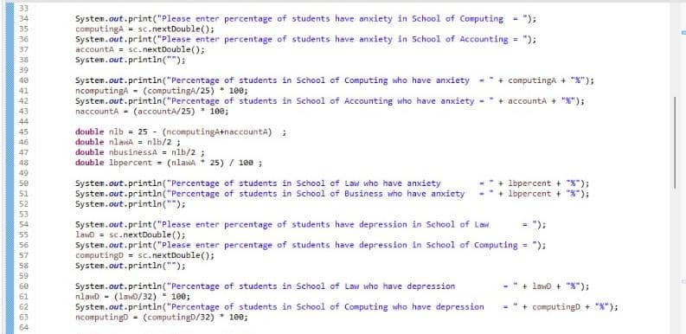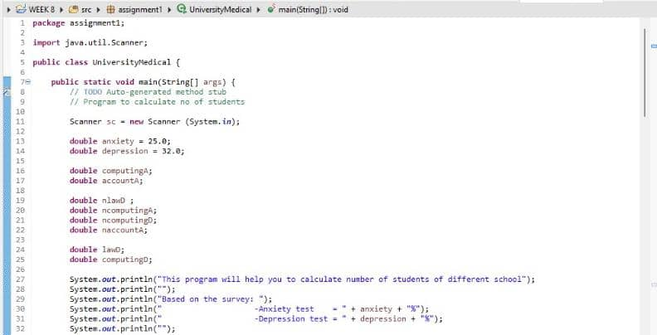**Coding**

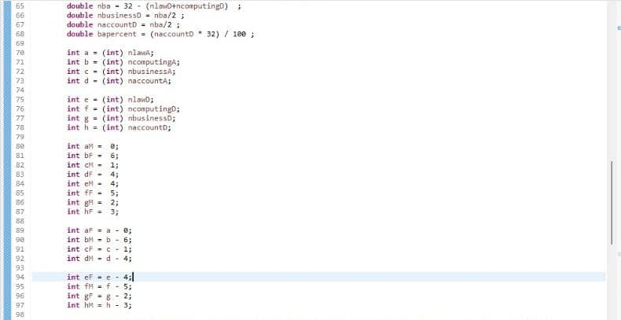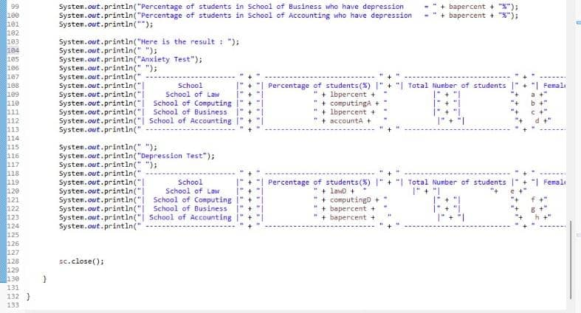

**Output**

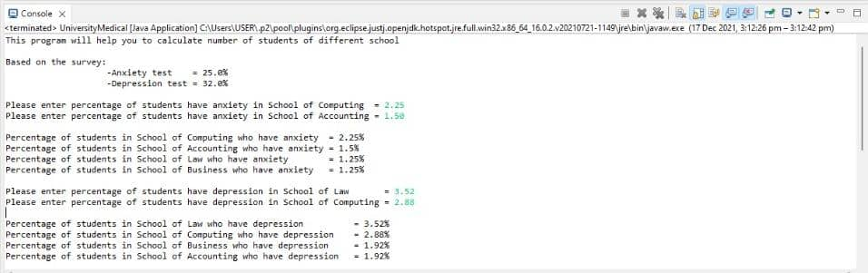

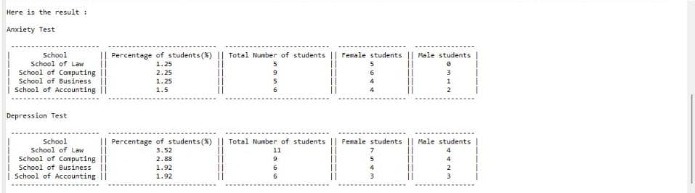

**REFERENCES**

1. Editorial Team. Create a Positive Ecosystem, Check 10 Benefits of Using The Salary Slip Application for Employees and Companies. (15th Sept, 2021). Retrieved from

[https://voi.id/en/lifestyle/85450/create-a-positive-ecosystem-check-10- benefits-of-using-the-salary-slip-application-for-employees-and- companies](https://voi.id/en/lifestyle/85450/create-a-positive-ecosystem-check-10-benefits-of-using-the-salary-slip-application-for-employees-and-companies)

1. Course (education). (August 5, 2021). *Wikipedia.*Retrieved December 15, 2021, from   
    <https://en.wikipedia.org/wiki/Course_(education)>
2. *What is the difference between a program, unit and course?*. (November 25, 2019). The  University of Adelaide. Retrieved from December 15, 2021, from <https://student.ask.adelaide.edu.au/app/answers/detail/a_id/2899/~/what-> is-the-difference-between-a-program%2C-unit-and-course%3F
3. *WHO Director-General’s opening remarks at the media briefing on COVID- 19 - 11 March 2020*. (2020, March 11). World Health Organization. Retrieved from [https://www.who.int/director- general/speeches/detail/who-director-general-s-opening-remarks-at- the-media-briefing-on-covid-19---11-march-2020](https://www.who.int/director-general/speeches/detail/who-director-general-s-opening-remarks-at-the-media-briefing-on-covid-19---11-march-2020" \t "https://word-edit.officeapps.live.com/we/_blank)